National University of Computer and Emerging Sciences, Lahore Campus

 | Course: | Data Structures | Course Code: | CS-218
 | Program: | BS (Computer Science) | Semester: | Spring 2020
 | Duration: | 60 Minutes | Total Marks: | 25
 | Paper Date: | 26th Feb-2020 | Page(s): | 3
 | Section: | All sections | Roll No.:
 | Exam: | MIDTERM-1
Instruction/Notes: | - Understanding question is a part of your exam. In case of ambiguity, write your assumptions and answer accordingly  - Time management is the key to success
Q1: [5]
Calculate time complexity of the following piece of code by formulating 𝑇(𝑛) and computing Big-O (tight bound).
int x=0;
for (int i=0; i< N; ++i){
for (int j=1; j<= 100; ++j){
for (int k=j; k<N; ++k){
x=x+i+j+k;
}
}
}

Q2: [5]
Write down code/ pseudocode using stack to determine if an input character string is of the form
$$A ∂ B$$
Where, A and B are substrings in the reverse order. For example, if A = abc, and B = cba , then abc ∂ cba must return true. Else, it must return false.

Q3: [10]
Given the following code for a Linked List:
class LinkedList {

struct Node {
int data;
Node* next;
};

Node* head;

public:

LinkedList() {
head = 0;
}

bool changeHead(int pos) {
//Your implementation
}
};
Provide an implementation of the function changeHead which changes the head of the Linked List to the required position. After changing the head, the list remains a valid Linked List.
A graphical representation of a Linked List is given below: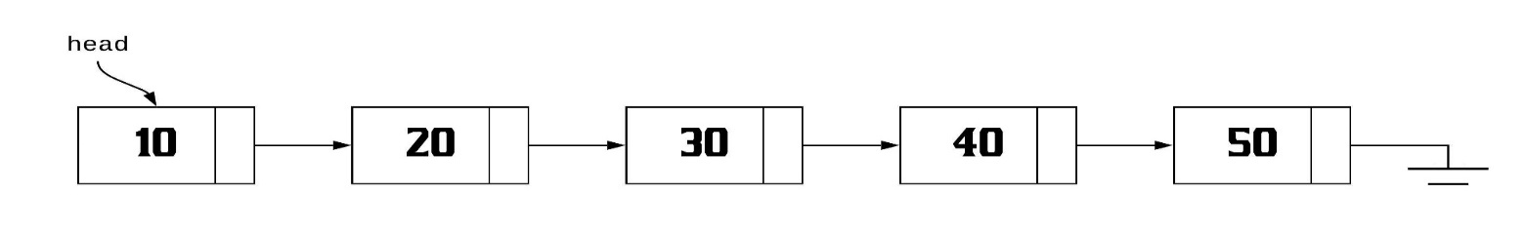
After calling changeHead(3) on this list, the resultant Linked List will look something like this: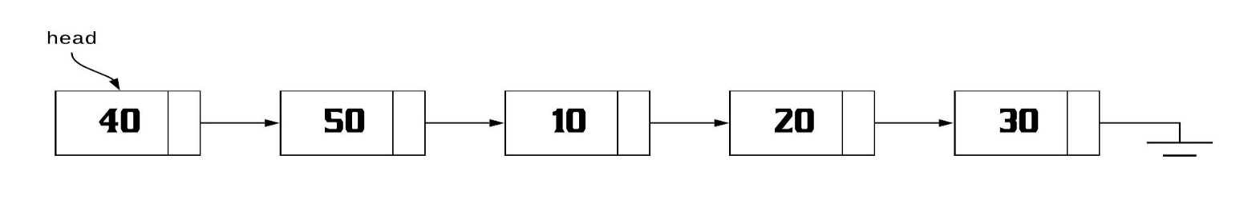

Q4: [5]
Consider the following function that takes reference to head of a Doubly Linked List as parameter. Assume that a node of doubly linked list has previous pointer as prev and next pointer as next. Suppose that reference of head of following Doubly Linked List is passed as an argument to the function
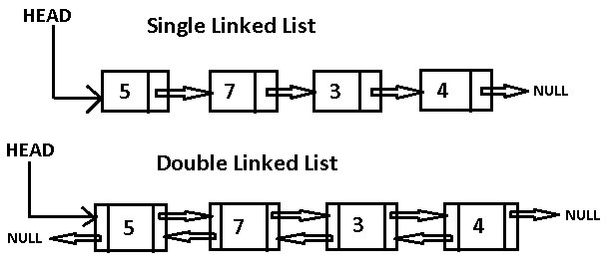
What will be the output of the function? Draw the modified linked list after the function call?
void foo(struct node *&head_ref)
{
struct node *temp = NULL;
struct node *current = head_ref;

while (current != NULL)
{
temp = current->prev;
current->prev = current->next;
current->next = temp;
current = current->prev;
}

if(temp != NULL )
head_ref = temp->prev;
}

